Analysis Me

**Fall**

2021

Technical Report

Team Members: Giancarlo Rinaldini, Chenqi Zhang

Instructor: Professor Jia Zhang

Enclosed in this document is the technical report of CS7340 <**Service Oriented Software Engineering**>.

Computer Science Department

Southern Methodist University

# Table of Contents

1. **Introduction**
2. **Motivation**
3. **Related work**
4. **Design**
5. **System implementation**
6. **Demo**
7. **Conclusions and recommended future work**

**Appendix:**

-Check in everything onto GitHub under the predefined directory including the following items

-Readme file: Describe briefly the purpose of the project, how to download and install the software, how to use the software

-src (sub-directory): include all source code categorized by packages

-lib (sub-directory): include all related library packages needed to support the project

-conf (sub-directory): include any confirmation settings and files

-app (sub-directory): any applications built on top of the APIs

-contact: please provide every team member’s contact information (cell number, personal email)

1. **Introduce**

For our final project, we have proposed a web app, called “Nation Switch”. This web app can dynamically display the national flag and other detailed information of the country according to the country selected by the user in the drop-down table.

Furthermore, this app will also dynamically mark every country which user has chosen on the map according to its geographical location. Referring to the location of the selected countries on the map, user can flexibly determine their travel route.

In addition, if user want to know differences between the language of target country and the language of his or her own country, this app also provides an interface linked to translation webpage.

1. **Motivation**

Globalization provides people of all countries opportunity to leave their countries temporarily and travel to all parts of the world for education, communication and sightseeing. Although travel plans of people all over the world are restricted now because of pandemic, we believe this situation will soon be conquered. In the past few decades, we have witnessed countless scientific, technological and cultural progresses which are contributed by people's cross-national cooperation and communication. That`s could be the main reason of why we decided to proposed a web app which will help people from all over the work to easily access the information of different countries and make preparations for further cooperation in the future.

1. **Related work**

The service targets the tourism audience that will visit Wikipedia pages and news outlets to learn about travel stops. Utility is to have an efficient method of accumulating important travel data such as currency, language, geographical location and quick access to google translate.

1. **Design**

We design our web app into two web pages. The first page is a quick login page. In the first page, there will be a preview of earth map and a “Go” button. After the “Go” button is clicked, our app will provide user the second page. In the second page, there will be the map with country marker which user can zoom in and zoom out, flag and detailed information of country, the scroll down list contained all of countries and a “translate” button linked to the translation web page.

1. **System Implementation**

From the vary beginning of this project, we have upgraded our *play* framework from 2.7.3 version to 2.8.0 version. After that, the code in our project will no longer adapted. So we should updated the code to adapt new version of play according to the Play Migration Guide.

After the update of Play framework and code, we have create a new function in HomeController and make sure there will be our quick start page popping up firstly. Then create our new login.html and create Mashup for Map API Leaflet in order to show sample map on web page. Next, create the main page of our web app and create Mashup for Map Leaflet API and REST Countries API separately. In addition, create a interface which will link to language translate web page. In the end, update the routes file, action function of buttons and scroll down menu in the web page.

1. **Demo**

From the first page, user can simply click GO button to learn countries information from this web app.

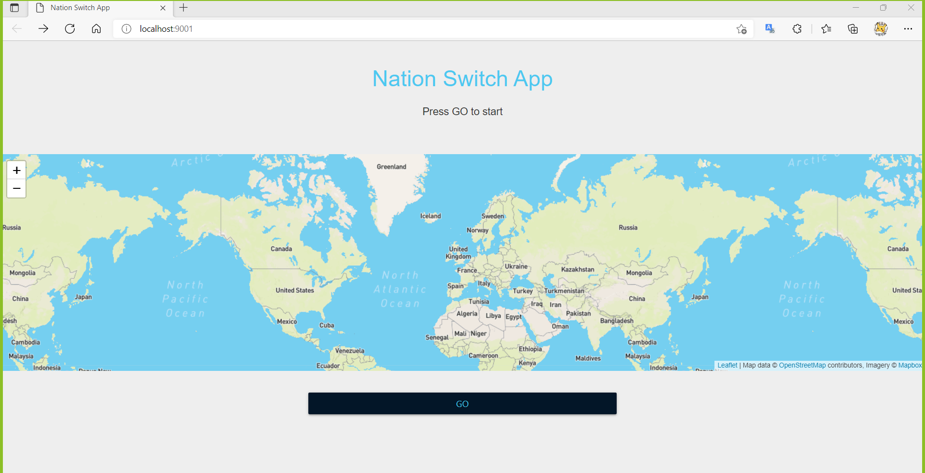

Figure 6.1

User can always select new countries. The markers on the map and detail information will be dynamically updated.

In the second page, user can browse the corresponding details of countries by select them in the scroll down menu. As the new country being selected, the markers on the map and detail information will be dynamically updated.

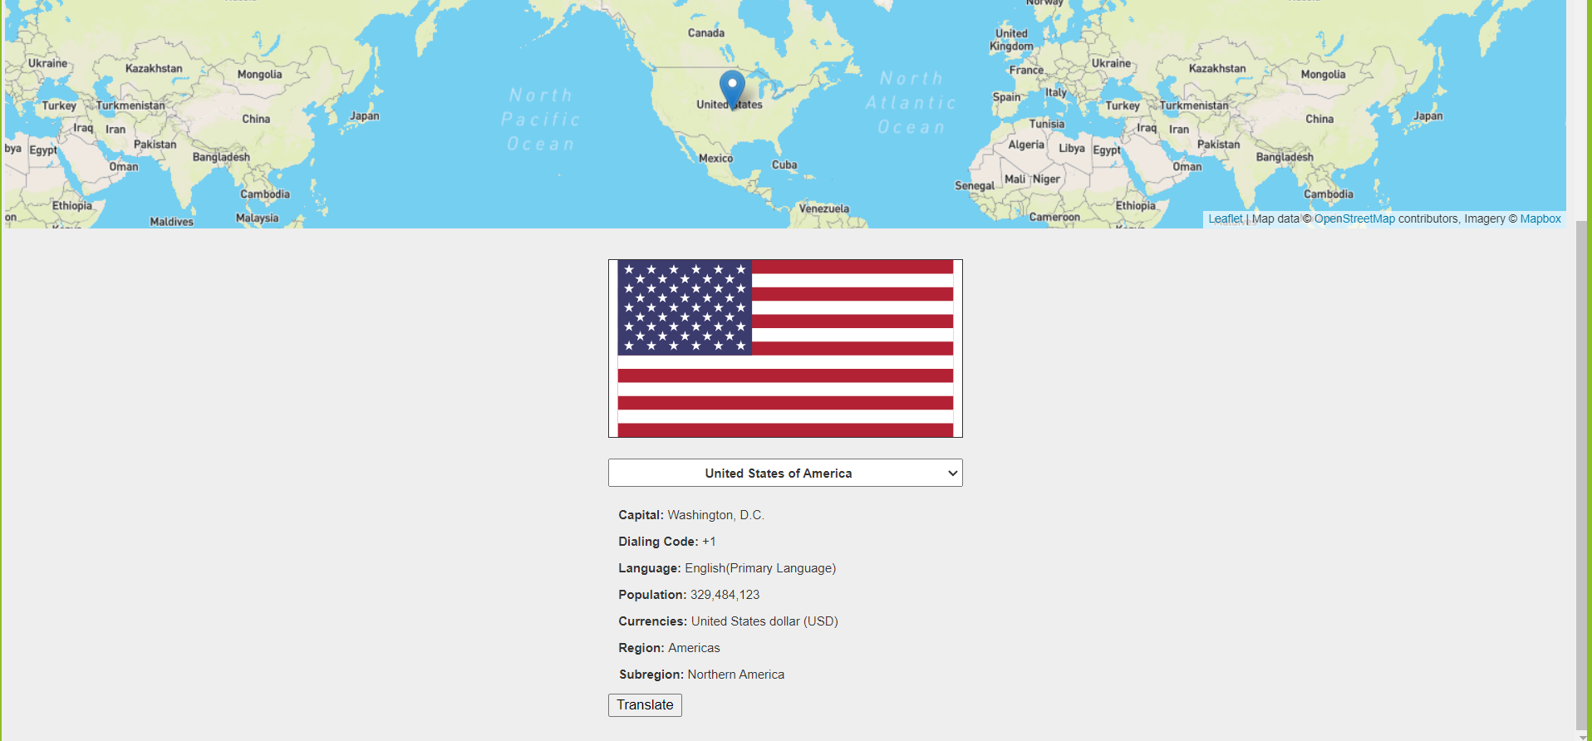

Figure 6.2

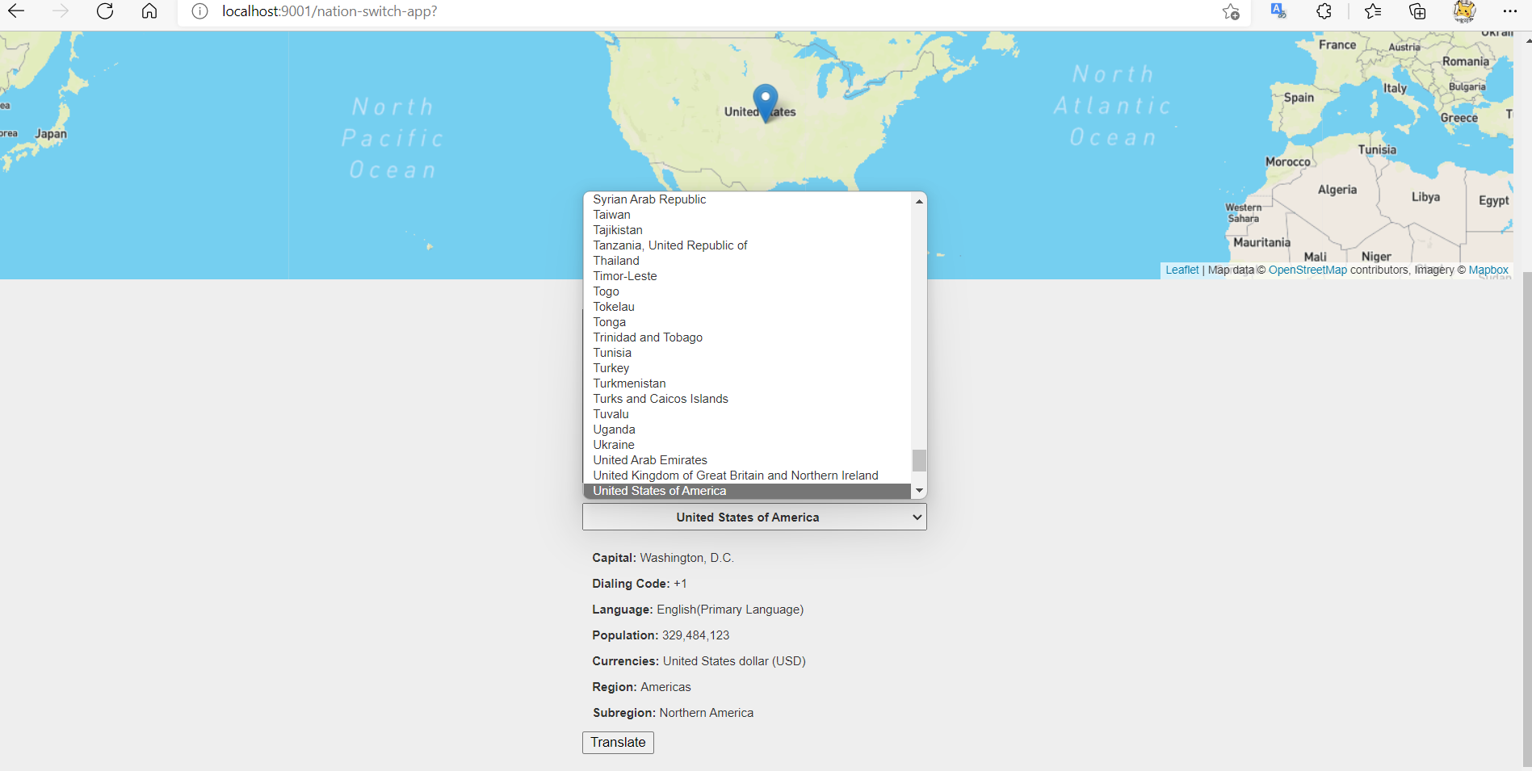

Figure 6.3

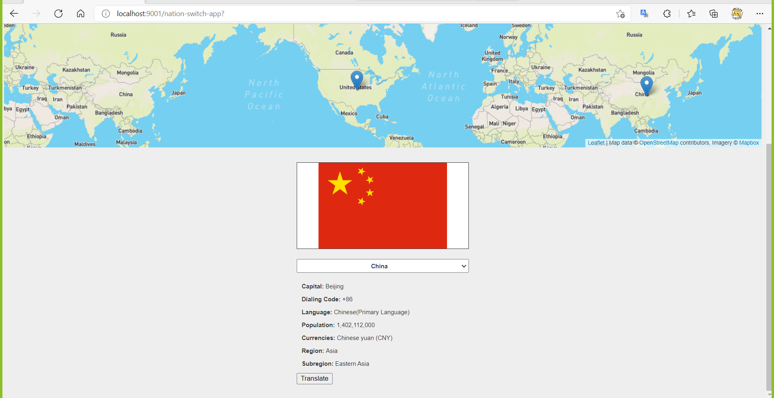

Figure 6.4

If user want to learn some basic local language for simple communicate, click Translate button and the translate web page will easily pop up.

1. **Conclusions and future work**

In our final project, we have provided user a web app which will help user to easily know more detailed information of countries and help them to better determine travel plans. Our web app is easy to access and contain meaningful functionality. We hope this Nations Switch app will become a useful tool for people who love to get to know other countries and communicate with their people.

In the future, we plan to add more detail information of selected countries, such as real-time weather information of main cities and pictures of landmark buildings of the country. We will also try to further optimize the user interface.